MAHATMA EDUCATION SOCIETY’S
PILLAI COLLEGE OF ARTS, COMMERCE & SCIENCE
(AUTONOMS) NEW PANVEL

PROJECT REPORT IDC BAF-MARKETING AND RETAIL MANAGEMENT
INDIGO
THE MARKETING JOURNEY OF INDIA’S MOST ON-TIME AIRLINE

IN PARTIAL FULFILLMENT
BACHELOR OF SCIENCE COMPUTER SCIENCE

SEMESTER II– 2025-26

PROJECT GUIDE
PROFESSOR. FIZA MIYAN

SUBMITTED BY
KRISHNA KAMLESH SINGH
ROLL NO. 1400

IndiGo: The Marketing Journey of India’s Most On-Time Airline

Part A: Case Study

1. Case Summary: What Happened? What Challenge or Idea Is Shown?
IndiGo Airlines, officially operated by InterGlobe Aviation Limited, was founded in 2006 by Rahul Bhatia and Rakesh Gangwal at a time when the Indian aviation industry was unstable, fragmented, and largely unprofitable. Several airlines had either shut down or were struggling financially due to high fuel costs, inefficient operations, poor fleet planning, and overambitious expansion strategies. For passengers, flying was often synonymous with uncertainty—delays were routine, cancellations frequent, and customer service inconsistent. This environment created a clear gap between what airlines were offering and what Indian passengers actually needed.

The Early Vision and Entry Strategy (2006–2010)
From the very beginning, IndiGo adopted a sharply defined vision: to provide affordable air travel while being consistently punctual, polite, and hassle-free. Unlike competitors who attempted to imitate international full-service carriers, IndiGo deliberately chose the low-cost carrier (LCC) model but refined it to suit Indian market realities. The founders believed that in a price-sensitive country like India, passengers would happily trade luxury for reliability and transparency.
One of the most critical early decisions was fleet standardization. IndiGo placed a landmark order for Airbus A320 aircraft even before commencing operations. Operating a single aircraft type reduced pilot training costs, simplified maintenance, ensured better spare-parts availability, and enabled faster aircraft turnaround times. This decision laid the foundation for IndiGo’s operational efficiency and later became a key marketing differentiator.
IndiGo launched operations in August 2006 with a focus on domestic routes connecting metro cities. Instead of aggressive advertising, the airline relied on disciplined execution. On-time departures, courteous cabin crew, and smooth ground operations quickly earned positive word-of-mouth. This phase marked the beginning of IndiGo’s philosophy that operations themselves are marketing.

Growth Phase and Market Consolidation (2010–2015)
Between 2010 and 2015, IndiGo steadily expanded its route network and fleet size. During this period, several competitors such as Kingfisher Airlines collapsed under heavy debt and poor cost control. Jet Airways, although strong, struggled with rising expenses. IndiGo, by contrast, remained profitable and debt-light.
The airline’s marketing message remained minimalistic and consistent. Campaigns focused on punctuality, transparency, and simplicity rather than glamour. Internally, IndiGo invested heavily in data-driven decision-making, crew productivity, and airport coordination to minimize delays. Aircraft turnaround times were reduced to as low as 25 minutes, among the best in the industry.
IndiGo also built a strong internal culture. Employees were trained to follow standard operating procedures strictly, ensuring uniform service quality across locations. This internal consistency translated into external brand reliability, strengthening customer trust.

Expansion, Internationalization, and Brand Leadership (2015–2019)
By 2015, IndiGo had become India’s largest airline by market share. The airline then began expanding aggressively into international short-haul routes across the Middle East, Southeast Asia, and South Asia. The same low-cost, high-efficiency model was applied internationally.
IndiGo placed one of the largest aircraft orders in aviation history, reinforcing its long-term growth strategy. The airline also introduced new aircraft variants such as the Airbus A320neo, which offered better fuel efficiency and lower operating costs. These decisions aligned with IndiGo’s cost-leadership positioning.
During this phase, IndiGo’s brand became synonymous with reliability. Business travelers increasingly preferred IndiGo for its predictability, while leisure travelers valued its affordability. Marketing communication continued to emphasize “on-time performance” as a core promise, backed by published performance data.

COVID-19 Impact and Recovery Strategy (2020–2022)
The COVID-19 pandemic posed an unprecedented challenge to the global aviation industry, including IndiGo. Flights were grounded, revenues collapsed, and operational uncertainties increased. Despite these challenges, IndiGo demonstrated resilience due to its strong balance sheet and disciplined cost management.
The airline focused on cash conservation, renegotiated leases, and optimized capacity deployment. As domestic travel gradually resumed, IndiGo was among the first airlines to scale up operations efficiently. Marketing during this period focused on safety, hygiene, and trust, reinforcing the brand’s reliability even during crisis.
Recent Developments and DGCA Conflicts (2023–Present)
In recent years, IndiGo has faced new challenges, particularly related to fleet management and regulatory scrutiny. A significant issue emerged with the grounding of several Airbus A320neo aircraft due to Pratt & Whitney engine problems. These groundings reduced available capacity, leading to flight cancellations and delays.
The Directorate General of Civil Aviation (DGCA), India’s aviation regulator, raised concerns over IndiGo’s operational disruptions, customer complaints, and aircraft availability. The DGCA issued advisories and warnings, urging IndiGo to improve passenger communication and ensure adequate spare aircraft availability.
These conflicts highlighted the tension between rapid expansion and operational resilience. IndiGo acknowledged the challenges and took corrective measures, including wet-leasing aircraft, adjusting schedules, and enhancing customer communication. From a marketing perspective, these issues tested IndiGo’s brand promise of reliability.
Despite these challenges, IndiGo maintained its market leadership. The airline communicated transparently about disruptions and continued to invest in long-term fleet expansion, including wide-body aircraft plans for long-haul international routes.
IndiGo Fleet Composition (As of Recent Data)
IndiGo operates one of the largest and youngest fleets in the world, primarily consisting of Airbus aircraft.The ATR fleet supports regional connectivity under India’s UDAN scheme, while the A321neo aircraft are used on high-density domestic and international routes.

Core Idea and Strategic Insight
The central idea demonstrated by IndiGo’s journey is that marketing success can be built on operational discipline rather than promotional excess. IndiGo transformed punctuality, cost control, and standardization into powerful brand assets. Even during regulatory conflicts and operational disruptions, the airline’s long-term credibility has allowed it to retain customer trust.
IndiGo’s story shows that in service industries, especially aviation, marketing is inseparable from execution. The airline’s ability to align its internal systems with its external brand promise remains the cornerstone of its sustained success.
Problem Identification (Detailed Industry and Competitive Perspective)When IndiGo entered the Indian aviation market, the problems it faced were not isolated to a single airline but deeply rooted in the structure and history of Indian civil aviation. For decades, the sector had witnessed repeated failures, policy constraints, finan
Aircraft Type | Number of Aircraft
Airbus A320ceo | ~80
Airbus A320neo | ~190
Airbus A321neo | ~70
ATR 72-600 | ~45
Total Fleet Size | ~385+ Aircraft
cial mismanagement, and inconsistent customer experiences. Understanding these problems is essential to appreciate why IndiGo’s strategy proved transformative.
One of the most fundamental problems was lack of sustainability among airlines. Early private players such as ModiLuft in the 1990s failed due to high costs, regulatory hurdles, and weak demand. Indian Airlines, the government-owned carrier, suffered from bureaucratic inefficiencies, aging fleets, frequent delays, and poor service quality. These issues created a perception that flying was unreliable and stressful.
Later entrants such as Kingfisher Airlines attempted to position themselves as premium lifestyle brands. While Kingfisher attracted attention through luxury, in-flight entertainment, and aggressive expansion, it failed to control costs and accumulated massive debt. Its collapse damaged passenger confidence and reinforced the belief that Indian airlines were unstable. Similarly, Go First (formerly GoAir) struggled with fleet groundings, financial distress, and operational disruptions, eventually suspending operations. Each airline failure widened the trust deficit between passengers and airlines.
Another major problem was extreme price sensitivity combined with low confidence in value delivery. Indian consumers wanted low fares but feared compromised safety and service. Low-cost carriers often cut prices without improving efficiency, resulting in poor punctuality and customer dissatisfaction. This created a vicious cycle where airlines competed only on price, eroding margins and service quality.
Operational inefficiency was a persistent challenge across the industry. Most airlines operated mixed fleets, increasing maintenance complexity and training expenses. Poor route planning, low aircraft utilization, and long turnaround times further inflated costs. These inefficiencies were ultimately passed on to customers in the form of delays, cancellations, and inconsistent service.
Regulatory and infrastructure constraints also posed problems. Congested airports, limited slots, and evolving DGCA regulations required airlines to maintain strict compliance and operational discipline. Many carriers failed to adapt quickly, leading to penalties, safety concerns, and operational breakdowns.
IndiGo also faced the challenge of market expansion beyond metro cities. Large parts of India remained underserved due to perceived low demand and poor airport infrastructure. Airlines hesitated to operate regional routes because of high costs and low yields. This limited air travel access for Tier-2, Tier-3, and remote regions, restricting overall market growth.
Thus, the core problems IndiGo needed to address were multi-dimensional: rebuilding passenger trust, ensuring safety without increasing costs, maintaining profitability in a price-sensitive market, differentiating itself from failed competitors, and expanding air connectivity across India.

Comparative Industry Challenges: IndiGo vs Major Indian Airlines
Airline | Business Model | Key Problems Faced | Outcome
ModiLuft | Early private carrier (1990s) | High costs, policy restrictions, weak demand | Ceased operations
Indian Airlines | Government-owned full-service | Bureaucracy, aging fleet, delays, poor service | Merged into Air India
Kingfisher Airlines | Premium full-service | Excessive debt, uncontrolled expansion, poor cost control | Bankruptcy & shutdown
Go First (GoAir) | Low-cost carrier | Engine issues, financial distress, fleet grounding | Operations suspended
IndiGo | Low-cost, efficiency-led | Price sensitivity, infrastructure limits, regulatory scrutiny | Market leader with sustained profitability

Decision Taken and Outcome (Strategic Response and Market Transformation)
To overcome these structural and competitive challenges, IndiGo adopted a disciplined, long-term strategy that combined operational efficiency with customer-focused marketing. The airline’s decisions not only ensured its own survival but also reshaped India’s aviation market.
One of the most important decisions was cost leadership through standardization. By operating a largely uniform Airbus fleet, IndiGo significantly reduced maintenance costs, pilot training expenses, and spare-parts inventory requirements. This allowed the airline to offer consistently low fares without compromising safety. Safety assurance was critical in rebuilding customer confidence, especially after multiple airline failures in India.
IndiGo also emphasized punctuality and reliability as non-negotiable standards. On-time performance was closely monitored and publicly communicated. This transparency differentiated IndiGo from competitors like Indian Airlines and Kingfisher, where delays were common. Over time, punctuality itself became a brand signal of professionalism and safety.
In terms of pricing, IndiGo adopted a transparent fare structure. Unlike many competitors, the airline avoided excessive hidden charges, which improved trust and reduced customer complaints. Lower operational costs enabled IndiGo to maintain affordable fares even during periods of rising fuel prices.
To expand the market, IndiGo aggressively increased its network reach. It connected major metros with smaller cities and participated actively in India’s regional connectivity initiatives. The introduction of ATR aircraft allowed IndiGo to serve short-haul and low-demand routes efficiently. This strategy helped achieve last-mile air connectivity, bringing first-time flyers into the aviation ecosystem.
IndiGo’s growth was also faster and more controlled than competitors. Instead of reckless expansion, the airline scaled capacity in line with demand and infrastructure readiness. This disciplined approach contrasted sharply with the aggressive but unsustainable growth of Kingfisher and Go First.
As a result of these decisions, IndiGo emerged as India’s largest airline by market share. It changed consumer expectations by proving that low fares could coexist with safety, punctuality, and professionalism. The airline’s success forced competitors to rethink their models and contributed to the overall maturation of India’s aviation market.
IndiGo did not merely grow within the market—it expanded the market itself by making air travel accessible, reliable, and widespread across India. Its outcomes demonstrate how strategic clarity and operational discipline can convert industry-wide problems into long-term competitive advantage.
Strategic Response Comparison: IndiGo vs Competitors
Strategic Dimension | IndiGo | Kingfisher | Go First | Indian Airlines
Fleet Strategy | Single-type, fuel-efficient | Mixed fleet | Narrow-body with engine dependency | Aging mixed fleet
Cost Control | Strict, process-driven | Weak | Moderate | Poor
Safety Perception | High, consistent | Initially high, later eroded | Affected by groundings | Low to moderate
Pricing | Low & transparent | Premium & high | Low but inconsistent | Regulated & inefficient
Network Expansion | Phased, demand-driven | Aggressive & unsustainable | Limited | Bureaucratic
Market Impact | Expanded aviation access nationwide | Short-term brand hype | Minimal | Legacy decline

Part B: Concepts Application
This section applies core marketing concepts directly to the IndiGo case discussed above. Instead of treating marketing as advertising alone, IndiGo’s journey clearly shows how modern marketing has evolved into a strategic, customer-centric, and execution-driven discipline.
1. Evolution of Marketing with Reference to IndiGo
The evolution of marketing can be understood in four broad stages: production-oriented marketing, product-oriented marketing, selling-oriented marketing, and customer-oriented (relationship) marketing. IndiGo’s strategy reflects this evolution clearly, especially in the context of the Indian aviation industry.
In the early years of Indian aviation, airlines followed a production-oriented approach, where the focus was simply on operating flights and adding capacity. Government-owned Indian Airlines represented this stage, where limited competition meant little focus on customer experience. Delays, inefficiency, and poor service were common, but customers had few alternatives.
This later evolved into a product-oriented stage, where airlines like Kingfisher focused on luxury features such as in-flight entertainment, premium meals, and brand glamour. However, this approach ignored the Indian market’s price sensitivity and resulted in unsustainable cost structures. The product was superior on paper, but it did not match customer priorities.
IndiGo consciously avoided these stages and adopted a customer-oriented and value-based marketing approach from inception. Through market understanding, IndiGo identified that Indian passengers primarily valued three things: affordability, punctuality, and predictability. Instead of adding features, IndiGo removed complexity. Its marketing focus shifted from selling seats to delivering reliable travel experiences.
In recent years, IndiGo has moved further into relationship and trust-based marketing. During crises such as COVID-19 and DGCA scrutiny, the airline focused on transparent communication, safety assurance, and long-term customer relationships. Thus, IndiGo represents the modern evolution of marketing where operational excellence, customer trust, and long-term value creation form the core of marketing strategy.

Evolution of Marketing: Traditional Airlines vs IndiGo
Marketing Stage | Traditional Indian Airlines | IndiGo’s Approach
Production | Capacity-focused | Efficiency-focused
Product | Luxury & features | Functional reliability
Selling | Promotions & branding | Experience delivery
Customer/Relationship | Weak loyalty | Trust and consistency

4Ps of Marketing Applied to IndiGo
The 4Ps framework—Product, Price, Place, and Promotion—helps explain how IndiGo designed a coherent and competitive marketing mix aligned with its strategy.

Product
IndiGo’s product is not luxury air travel but safe, punctual, and hassle-free transportation. The airline offers standardized seating, clean cabins, polite service, and reliable schedules. By limiting unnecessary frills, IndiGo ensures consistency across flights. Safety, operational discipline, and on-time performance form the core product attributes.

Price
IndiGo follows a low-cost, transparent pricing strategy. Lower operating costs achieved through fleet standardization and high aircraft utilization allow IndiGo to offer competitive fares. Unlike many competitors, IndiGo avoids excessive hidden charges, improving customer trust. Pricing is dynamic but predictable, reinforcing value-for-money perception.

Place
Place refers to distribution and accessibility. IndiGo has built the widest domestic network in India, covering metros, Tier-2, Tier-3 cities, and remote regions through ATR operations. High-frequency flights ensure better connectivity and last-mile access. Online booking platforms, mobile apps, and travel aggregators make the airline easily accessible.

Promotion
IndiGo’s promotion strategy is minimalistic and message-driven. Instead of celebrity endorsements or emotional storytelling, promotions focus on punctuality, reliability, and simplicity. Performance metrics themselves act as promotional tools. During disruptions, transparent communication becomes part of promotion by reinforcing trust.

4Ps Comparison: IndiGo vs Full-Service Airlines
4Ps | IndiGo | Full-Service Airlines
Product | Reliable, no-frills | Luxury-focused
Price | Low, transparent | High, bundled
Place | Extensive domestic & regional | Selective routes
Promotion | Trust & performance-based | Image & lifestyle-based

4Cs of Marketing Applied to IndiGo
The 4Cs framework shifts focus from the company to the customer. IndiGo’s success can be strongly explained using this model.

Customer
IndiGo targets time-sensitive, value-conscious passengers, including business travelers, first-time flyers, and middle-class families. The airline understands customer expectations clearly and avoids overpromising. Its consistent service builds long-term customer trust.

Cost
Cost is viewed as the total cost to the customer, including ticket price, time, stress, and uncertainty. IndiGo minimizes indirect costs by ensuring punctuality and reducing delays. This holistic cost advantage differentiates IndiGo from competitors.

Convenience
IndiGo emphasizes convenience through easy booking, frequent flight schedules, smooth check-in processes, and extensive route coverage. Regional connectivity ensures that even smaller cities are conveniently linked to major hubs.

Communication
Communication at IndiGo is simple, transparent, and operationally aligned. Whether through digital notifications, announcements, or regulatory disclosures, IndiGo maintains clarity. During DGCA-related disruptions, communication became a key tool for maintaining brand credibility.

4Cs Comparison: IndiGo vs Traditional Airlines
4Cs | IndiGo | Traditional Airlines
Customer | Clearly defined | Broad & unclear
Cost | Low total cost | Hidden & variable
Convenience | High-frequency & reach | Limited accessibility
Communication | Transparent & factual | Inconsistent

Part C: Analysis (How IndiGo Used Marketing Strategies to Solve Problems and Grow)
IndiGo’s growth story shows how marketing, when aligned with operations and strategy, can help a company overcome severe industry challenges. IndiGo did not rely on aggressive advertising or emotional branding. Instead, it used performance-based marketing, where every operational decision reinforced its brand promise. The following analysis explains this in simple and structured points.
What Did IndiGo Do Well?
• Clear Brand Positioning
IndiGo positioned itself very clearly as a low-cost, on-time, and reliable airline. While competitors tried to be everything to everyone, IndiGo focused on one strong promise: punctual and affordable travel. This clarity helped customers easily understand and trust the brand.
• Operations as Marketing
IndiGo treated operational efficiency as its main marketing tool. Faster turnaround times, standardized aircraft, and disciplined crew management ensured punctuality. Every on-time flight acted as a live advertisement for the brand.
• Cost Leadership Without Compromising Safety
By controlling costs through fleet standardization and high aircraft utilization, IndiGo offered low fares while maintaining strong safety standards. This addressed a major customer fear in India—that low price means low safety.
• Building Trust After Industry Failures
After the collapse of airlines like Kingfisher and Go First, passengers were worried about reliability. IndiGo rebuilt trust by consistently delivering on its promises, maintaining transparency, and avoiding overexpansion.
• Market Expansion and Last-Mile Connectivity
IndiGo did not limit itself to metro cities. Through regional routes and ATR aircraft, it connected Tier-2, Tier-3, and remote cities. This helped create first-time flyers and expanded the overall aviation market in India.
• Strong Response During Crises
During COVID-19 and DGCA-related challenges, IndiGo focused on safety, communication, and long-term stability instead of short-term profits. This strengthened its image as a responsible and dependable airline.

What Could IndiGo Improve?
• Crisis Communication During Disruptions
Although IndiGo is operationally strong, recent aircraft groundings and DGCA warnings exposed gaps in customer communication. Clearer, faster, and more empathetic communication during delays and cancellations would improve customer satisfaction.
• Customer Loyalty Programs
IndiGo’s loyalty program is functional but not emotionally engaging. Strengthening rewards, partnerships, and personalization could improve repeat customer engagement, especially among frequent business travelers.
• Handling Rapid Scale with Resilience
Rapid fleet expansion has sometimes stressed operations. IndiGo needs stronger contingency planning to manage disruptions without affecting punctuality and brand trust.
• Limited Premium Options
As customer expectations evolve, IndiGo could selectively introduce paid premium services (such as flexible tickets or enhanced seating) without diluting its low-cost positioning.

Safety Record and the 21 May 2025 Delhi–Srinagar Incident
IndiGo has consistently maintained one of the strongest safety records in Indian aviation, supported by strict adherence to standard operating procedures, continuous pilot training, and regulatory compliance. A defining example of this safety-first culture was demonstrated during the Delhi–Srinagar flight (6E-2147) on 21 May 2025, which encountered one of the most challenging weather-related situations in recent Indian aviation history.
The Airbus A321 aircraft, carrying over 220 passengers, encountered severe turbulence and a hailstorm while cruising at 36,000 feet near Pathankot. Upon detecting extreme weather conditions, the flight crew initially attempted to deviate from the storm. However, due to airspace restrictions—first from Indian Air Force Northern Control and later from Lahore Air Traffic Control, owing to existing NOTAM restrictions—the crew was unable to alter the route.
As the aircraft approached the thunderstorm cloud, the pilots briefly considered returning to Delhi. However, given their proximity to the storm system, they made the calculated decision to penetrate the weather system via the shortest route toward Srinagar to ensure a quicker exit from hazardous conditions. During this phase, the aircraft experienced hailstorm impact, severe turbulence, strong updrafts and downdrafts, and multiple technical warnings, including maximum operating speed alerts, angle-of-attack faults, unreliable speed indications, loss of alternate law protections, and repeated stall warnings.
Due to the intensity of turbulence, the autopilot disengaged, and the aircraft’s rate of descent momentarily reached 8,500 feet per minute. The pilots immediately took full manual control, managed wide speed variations, and continued to fly the aircraft manually until they exited the hailstorm. After completing all required ECAM checklist actions, the crew declared PAN-PAN (urgency call) to Srinagar ATC and requested radar vectors.
With professional coordination from air traffic authorities, the aircraft landed safely at Srinagar, with no injuries or fatalities reported. A post-flight inspection revealed damage to the aircraft’s nose radome, caused by hail impact. The DGCA initiated a routine investigation, which highlighted the crew’s sound judgment, calm decision-making, and strict adherence to safety protocols under extreme operational stress. From a brand and marketing perspective, the incident reinforced IndiGo’s image as an airline that prioritizes passenger safety over operational convenience, even in the most adverse conditions.

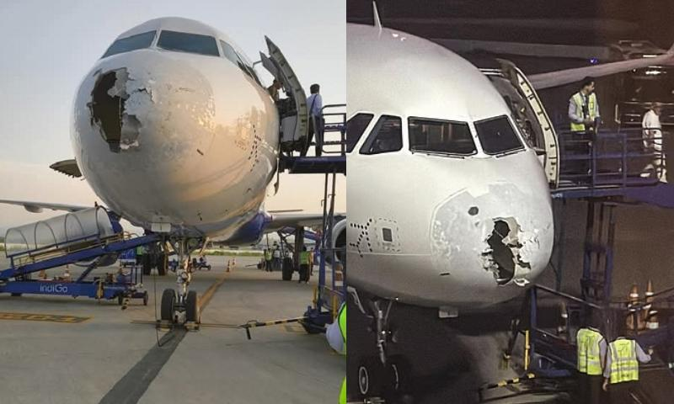
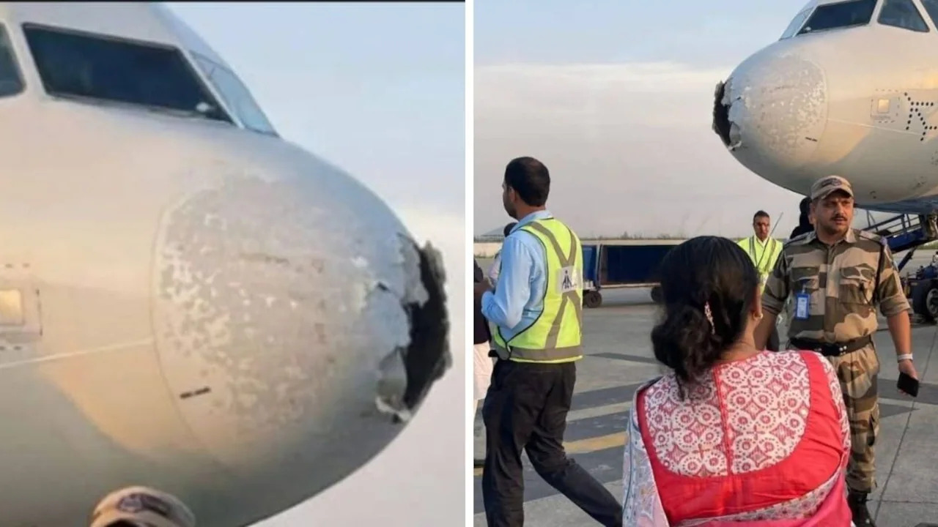
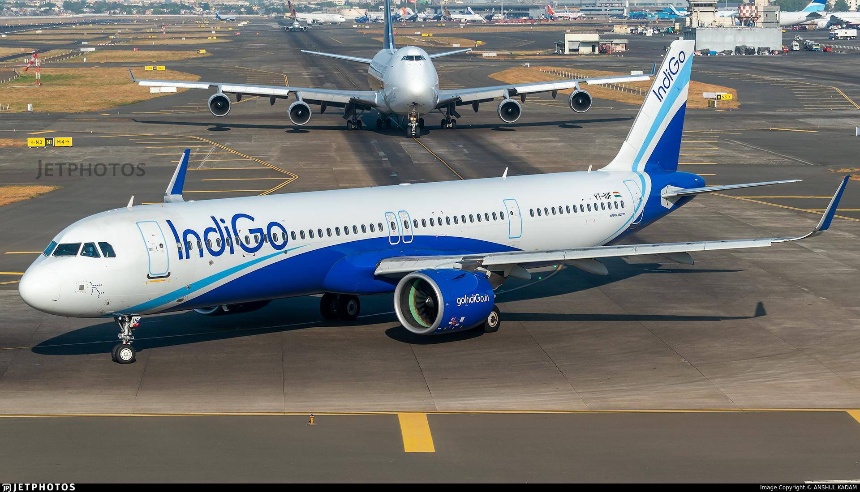
DGCA Conflict and Operational Chaos (November–December 2025)
Later in the year, between late November and mid-December 2025, IndiGo faced a major regulatory confrontation with the Directorate General of Civil Aviation (DGCA) amid widespread disruption in the Indian aviation market. During this period, thousands of IndiGo flights were cancelled or delayed, leading to severe passenger inconvenience and an atmosphere of chaos across domestic air travel.
The crisis stemmed from a combination of aircraft groundings, capacity shortages, maintenance challenges, and scheduling pressures—issues amplified by IndiGo’s dominant market position, with nearly 65% share of India’s domestic aviation market. Due to this dominance, disruptions at IndiGo effectively brought large sections of the domestic aviation ecosystem to a standstill, leaving passengers with limited alternatives and intensifying public dissatisfaction.
The DGCA issued multiple notices to IndiGo, citing operational reliability, passenger grievance management, and service continuity concerns. However, the situation also highlighted the duopoly dynamics of the Indian aviation sector, where the market’s heavy dependence on one airline magnified the systemic impact of operational disruptions. IndiGo’s strategic leverage within this structure played a critical role, as grounding or penalizing the airline too aggressively risked further destabilizing the entire domestic market.
Eventually, following negotiations and IndiGo’s assurance of corrective measures—including wet-leasing aircraft, revising flight schedules, improving spare part availability, and strengthening passenger communication—the DGCA softened and reversed certain notices. While passengers bore the brunt of the disruption, the episode underscored the complex balance regulators must maintain between enforcement and market stability in a highly concentrated aviation industry.
From a marketing and strategic perspective, the DGCA conflict exposed the risks of rapid scale and market dominance, but also reaffirmed IndiGo’s systemic importance in Indian aviation—an airline whose operational decisions can influence the entire sector’s functioning.

Summary Table: Problems, Marketing Strategy, and Outcomes
Industry Problem | IndiGo’s Marketing & Operational Strategy | Outcome
Low trust in airlines | Punctuality as brand promise | Strong customer confidence
Price sensitivity | Cost leadership & transparent pricing | High load factors
Safety concerns | Fleet standardization & strict SOPs | Strong safety perception
Airline failures | Disciplined expansion | Long-term sustainability
Limited regional access | ATR fleet & regional routes | Market expansion
Regulatory scrutiny | Compliance & corrective action | Maintained leadership

Key Marketing Lessons from IndiGo
• Marketing Is More Than Advertising
IndiGo proves that marketing is not just about promotions. Reliable service delivery, safety, and punctuality communicate the brand message more powerfully than advertisements.
• Consistency Builds Strong Brands
By delivering the same experience across cities and years, IndiGo built strong brand trust. Consistency matters more than creativity in service industries.
• Customer Pain Points Should Drive Strategy
IndiGo succeeded by solving real customer problems—delays, high fares, and uncertainty—rather than adding unnecessary features.
• Operational Discipline Creates Competitive Advantage
Strong processes and cost control helped IndiGo survive where others failed. Operational excellence can be a long-term marketing advantage.
• Market Creation Is Better Than Market Competition
Instead of fighting only for existing passengers, IndiGo expanded the market by making air travel accessible to new regions and new customer segments.

Conclusion
IndiGo’s journey clearly demonstrates how a well-defined marketing philosophy, when tightly integrated with operational discipline, can transform an entire industry. In an Indian aviation market long marked by airline failures, poor punctuality, weak customer trust, and financial instability, IndiGo adopted a fundamentally different approach. Rather than depending on aggressive promotions, luxury positioning, or emotional branding, the airline built its brand on execution—on-time performance, cost efficiency, safety, and consistency. This strategy not only ensured IndiGo’s survival in a difficult industry but also helped it emerge as India’s most reliable and profitable airline.
From its inception, IndiGo showed a deep understanding of the Indian passenger’s priorities: affordability without compromising safety, predictability over glamour, and simplicity over complexity. Through fleet standardization, strict standard operating procedures, and an unwavering focus on punctuality, IndiGo transformed internal efficiencies into strong external brand value. Each on-time flight reinforced its marketing promise, clearly proving that in service industries, operations themselves function as the most powerful form of marketing communication.
IndiGo’s role in rebuilding passenger trust after repeated airline collapses such as Kingfisher and Go First is particularly noteworthy. At a time when flying in India was associated with uncertainty and inconvenience, IndiGo delivered consistency and reliability. Transparent pricing, disciplined and demand-driven expansion, and active participation in regional connectivity initiatives helped the airline expand the aviation market rather than merely compete within it. By connecting Tier-2 and Tier-3 cities and serving first-time flyers, IndiGo played a major role in democratizing air travel in India.
Even during periods of severe crisis—including the COVID-19 pandemic, aircraft groundings caused by engine issues, and heightened scrutiny from the DGCA—IndiGo largely stayed aligned with its core values. These phases exposed the risks of rapid scale and heavy dependence on a single aircraft family, yet the airline responded through corrective measures such as wet-leasing aircraft, schedule rationalization, cost control, and improved passenger communication. Importantly, IndiGo continues to maintain a strong safety record, with only one officially reported incident on 21 May 2025 and no fatalities or injuries, reinforcing the message that cost leadership does not come at the expense of safety.
However, recent events from late November to mid-December 2025 marked a challenging phase for IndiGo’s public perception. A series of flight cancellations, prolonged delays, and operational disruptions led to widespread passenger dissatisfaction, increased complaints, and legal cases filed by affected customers. For many travelers, these incidents directly conflicted with IndiGo’s long-standing promise of punctual and hassle-free travel. This period clearly showed that when a dominant airline faces disruption, the impact on passengers is widespread and severe.
These developments also triggered a broader realization at the policy level. With IndiGo holding close to 65% of India’s domestic aviation market share, the Indian aviation sector has effectively moved towards a duopoly structure. The Ministry of Civil Aviation and the DGCA recognized that such concentration is potentially dangerous for a growing aviation market. When one airline controls a majority of capacity, operational failures can affect national connectivity, reduce consumer choice, and amplify passenger hardship. Consequently, the DGCA and the Ministry of Civil Aviation took further action against IndiGo through stricter monitoring, advisories, demands for better contingency planning, and stronger emphasis on passenger communication and regulatory compliance.
Thus, while IndiGo’s dominance reflects exceptional operational efficiency and strategic clarity, it also raises critical concerns about market balance, competition, and long-term consumer welfare. Excessive concentration can weaken competitive pressure, limit innovation, and pose systemic risks to the aviation ecosystem if not carefully regulated.
In conclusion, IndiGo stands as a landmark case of how marketing rooted in operational excellence can create enduring competitive advantage. Its journey offers powerful lessons for organizations across sectors: understand customer pain points, deliver consistently, grow responsibly, and allow performance to speak louder than promotion. At the same time, IndiGo’s scale highlights an equally important lesson—that industry leadership must be matched with accountability and regulatory foresight. For India’s aviation market to remain bright, resilient, and passenger-centric, strong airlines must coexist with healthy competition and vigilant regulation.

----- END OF REPORT -----

REPORT BY: 1400. KRISHNA KAMLESH SINGH (FY BSC CS- C 2025-26)
DATE: 15TH DECEMBER 2025

